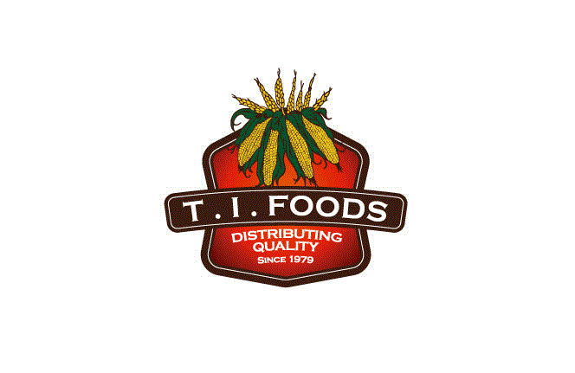 Tortillas Incorporated
2912 N Commerce Street
N. Las Vegas, NV 89030
702.399.3300 ext. 226
702.399.5914 fax

Letter of Continuing Guarantee

To Whom it may concern:

Tortillas Incorporated (dba) Los Arcos hereby guarantees that all products that all products and goods sold by Tortillas Incorporated have not been adulterated as defined by the Federal Food, Drug, and Cosmetic Act 8 (United States Code, Title 21, Chapter 9. Section 342). We manufacture in accordance with the applicable regulations.

The seller further guarantees that if any article contains a color additive or allergen, said additive or allergen has been, is and will be identified as present in the ingredient listing.

The guarantees given herein are continuing and shall be in full force and effect until revoked in writing.

Signed by,
Tortillas Incorporated

