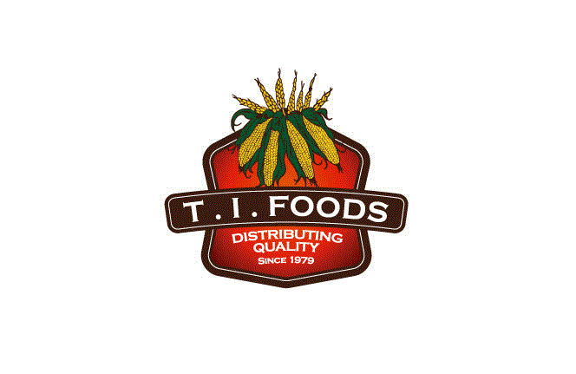 Tortillas Incorporated
2912 N Commerce Street
N. Las Vegas, NV 89030
702.399.3300 ext. 226
702.399.5914 fax

March 8, 2023
Ref. https://www.p65warnings.ca.gov/fact-sheets/foods

Tortillas Incorporated dba, Los Arcos, Garden Valley Foods, TI Foods, all packaging materials, and ingredients are compliant with California Prop65 we do not use extra labels on our products.

Signed by,
TORTILLAS INCORPORATED

